*Petar Petrović* [1]

*Institution, Place/Country*

*Jovan Jovanović* [2]

*Institution, Place/Country*

# Title of paper

Abstract:

Abstract should be written in Cambria font with 10 pt size in italic mode. You are asked to write abstract in maximum range of 1000 characters.

**Keywords:** e.g. Entrepreneurship, Engineering, Management, Education, …

## Introduction

Paragraph should be written in Cambria font with 12 pt size. Use spacing ”After” with 6 pt value in order to separate paragraphs.

Maximum page number by paper is 8 pages. All papers will be peer reviwed. Accepted papers will be published in the Conference Proceedings. Papers by invited speakers are beyond this restriction. Papers should be written in English.

References should be put in brackets [1], consecutively. See the REFERENCES part of this instruction.

## 1. Charts, tables, pictures, photos

You are asked to use MS Visio, Corel 12 (or newer ones) or MS Word for your charts and tables. Scanned or ”copy-pasted” photos should be edited in Photoshop, in order to gain quality acceptable for printing. An example for picture placement into the paper is shown bellow.

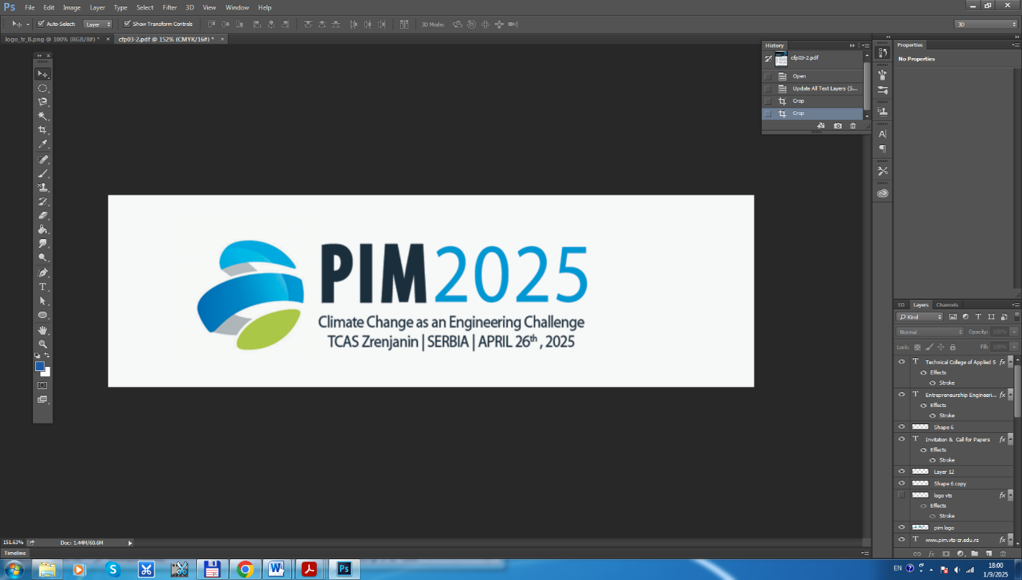

**Picture 1.** Name of the picture

You are asked to adjust the both, font type and font size in the pictures, tables and in any other object with the font characteristics in main text of the paper.

**Table 1:** Name of the table

|  |  |  |  |
| --- | --- | --- | --- |
| ***No.*** | ***Attribute 1*** | ***Attribute 2*** | ***Attribute 3*** |
| 1. |  |  |  |
| 2. |  |  |  |
| 3. |  |  |  |

Source**:** Name of the source

## REFERENCES

1. Aleksić, A. (Year of publishing). *Title*. Place of publishing: Publisher.
2. Wagner, A. and Bajsić, I. (2004). Measurement of the surface-temperature field in a fog lamp using resistance-based temperature detectors. Strojniški vestnik – Journal of Mechanical Engineering, 50(2), 72-79.
3. Boguslawski, L. (2004). Influence of pressure fluctuations distribution on local heat transfer on flat surface impinged by turbulent free jet. Proceedings of International Thermal Science Seminar II, Bled, June 13-16th 2004.
4. Černiček, I., & Molnar, R. (1988). Razvoj profitnih potencijala preduzetničkih organizacija. In I. Černiček & R. Molnar (Eds.), Razvoj preduzetništva - šansa za progres (pp. 25-43). Zrenjanin, Serbia: Tehnički fakultet “Mihajlo Pupin”.
5. Drucker, P. F., & Maciaiello, J. A. (2008). Management (Revised ed.). HarperCollins e-books. Retrieved August 1st 2016, from Youth Portal web site: <http://youth-portal.com/wp-content/uploads/2014/10/Peter-F-Drucker-Management-Rev-Ed.pdf>
6. EUROSTAT. (2024). *Business demography statistics - Enterprise Survival Rate*. Retrieved May 13th 2024, from Eurostat web site: [http://ec.europa.eu/eurostat/statistics-explained/index.php/ Business_demography _statistics](http://ec.europa.eu/eurostat/statistics-explained/index.php/%20Business_demography%20_statistics)

1. E-mail, other contacts (optional, ie. ORCID)
2. E-mail, other contacts (optional, ie. ORCID)